**Exp-6 Predictive Parsing Table**

**Name: -** Sai Mohit Ambekar

**Reg No: -** RA1911031010137

**Class: -** CSE-IT (L2 Section)

**Aim:**

To write a program to perform a predictive parsing table.

**Code:**

#include <stdio.h>

#include <string.h>

int main()

{

char fin[10][20], st[10][20], ft[20][20], fol[20][20];

int a = 0, e, i, t, b, c, n, k, l = 0, j, s, m, p;

printf("enter the no. of nonterminals\n");

scanf("%d", &n);

printf("enter the productions in a grammar\n");

for (i = 0; i < n; i++)

scanf("%s", st[i]);

for (i = 0; i < n; i++)

fol[i][0] = '\0';

for (s = 0; s < n; s++)

{

for (i = 0; i < n; i++)

{

j = 3;

l = 0;

a = 0;

l1:

if (!((st[i][j] > 64) && (st[i][j] < 91)))

{

for (m = 0; m < l; m++)

{

if (ft[i][m] == st[i][j])

goto s1;

}

ft[i][l] = st[i][j];

l = l + 1;

s1:

j = j + 1;

}

else

{

if (s > 0)

{

while (st[i][j] != st[a][0])

{

a++;

}

b = 0;

while (ft[a][b] != '\0')

{

for (m = 0; m < l; m++)

{

if (ft[i][m] == ft[a][b])

goto s2;

}

ft[i][l] = ft[a][b];

l = l + 1;

s2:

b = b + 1;

}

}

}

while (st[i][j] != '\0')

{

if (st[i][j] == '|')

{

j = j + 1;

goto l1;

}

j = j + 1;

}

ft[i][l] = '\0';

}

}

printf("\n");

printf("first \n");

for (i = 0; i < n; i++)

printf("FIRS[%c]=%s\n", st[i][0], ft[i]);

fol[0][0] = '$';

for (i = 0; i < n; i++)

{

k = 0;

j = 3;

if (i == 0)

l = 1;

else

l = 0;

k1:

while ((st[i][0] != st[k][j]) && (k < n))

{

if (st[k][j] == '\0')

{

k++;

j = 2;

}

j++;

}

j = j + 1;

if (st[i][0] == st[k][j - 1])

{

if ((st[k][j] != '|') && (st[k][j] != '\0'))

{

a = 0;

if (!((st[k][j] > 64) && (st[k][j] < 91)))

{

for (m = 0; m < l; m++)

{

if (fol[i][m] == st[k][j])

goto q3;

}

fol[i][l] = st[k][j];

l++;

q3:;

}

else

{

while (st[k][j] != st[a][0])

{

a++;

}

p = 0;

while (ft[a][p] != '\0')

{

if (ft[a][p] != '@')

{

for (m = 0; m < l; m++)

{

if (fol[i][m] == ft[a][p])

goto q2;

}

fol[i][l] = ft[a][p];

l = l + 1;

}

else

e = 1;

q2:

p++;

}

if (e == 1)

{

e = 0;

goto a1;

}

}

}

else

{

a1:

c = 0;

a = 0;

while (st[k][0] != st[a][0])

{

a++;

}

while ((fol[a][c] != '\0') && (st[a][0] != st[i][0]))

{

for (m = 0; m < l; m++)

{

if (fol[i][m] == fol[a][c])

goto q1;

}

fol[i][l] = fol[a][c];

l++;

q1:

c++;

}

}

goto k1;

}

fol[i][l] = '\0';

}

printf("\n");

printf("follow \n");

for (i = 0; i < n; i++)

printf("FOLLOW[%c]=%s\n", st[i][0], fol[i]);

printf("\n");

s = 0;

for (i = 0; i < n; i++)

{

j = 3;

while (st[i][j] != '\0')

{

if ((st[i][j - 1] == '|') || (j == 3))

{

for (p = 0; p <= 2; p++)

{

fin[s][p] = st[i][p];

}

t = j;

for (p = 3; ((st[i][j] != '|') && (st[i][j] != '\0')); p++)

{

fin[s][p] = st[i][j];

j++;

}

fin[s][p] = '\0';

if (st[i][k] == '@')

{

b = 0;

a = 0;

while (st[a][0] != st[i][0])

{

a++;

}

while (fol[a][b] != '\0')

{

printf("M[%c,%c]=%s\n", st[i][0], fol[a][b], fin[s]);

b++;

}

}

else if (!((st[i][t] > 64) && (st[i][t] < 91)))

printf("M[%c,%c]=%s\n", st[i][0], st[i][t], fin[s]);

else

{

b = 0;

a = 0;

while (st[a][0] != st[i][3])

{

a++;

}

while (ft[a][b] != '\0')

{

printf("M[%c,%c]=%s\n", st[i][0], ft[a][b], fin[s]);

b++;

}

}

s++;

}

if (st[i][j] == '|')

j++;

}

}

}

**Output:**

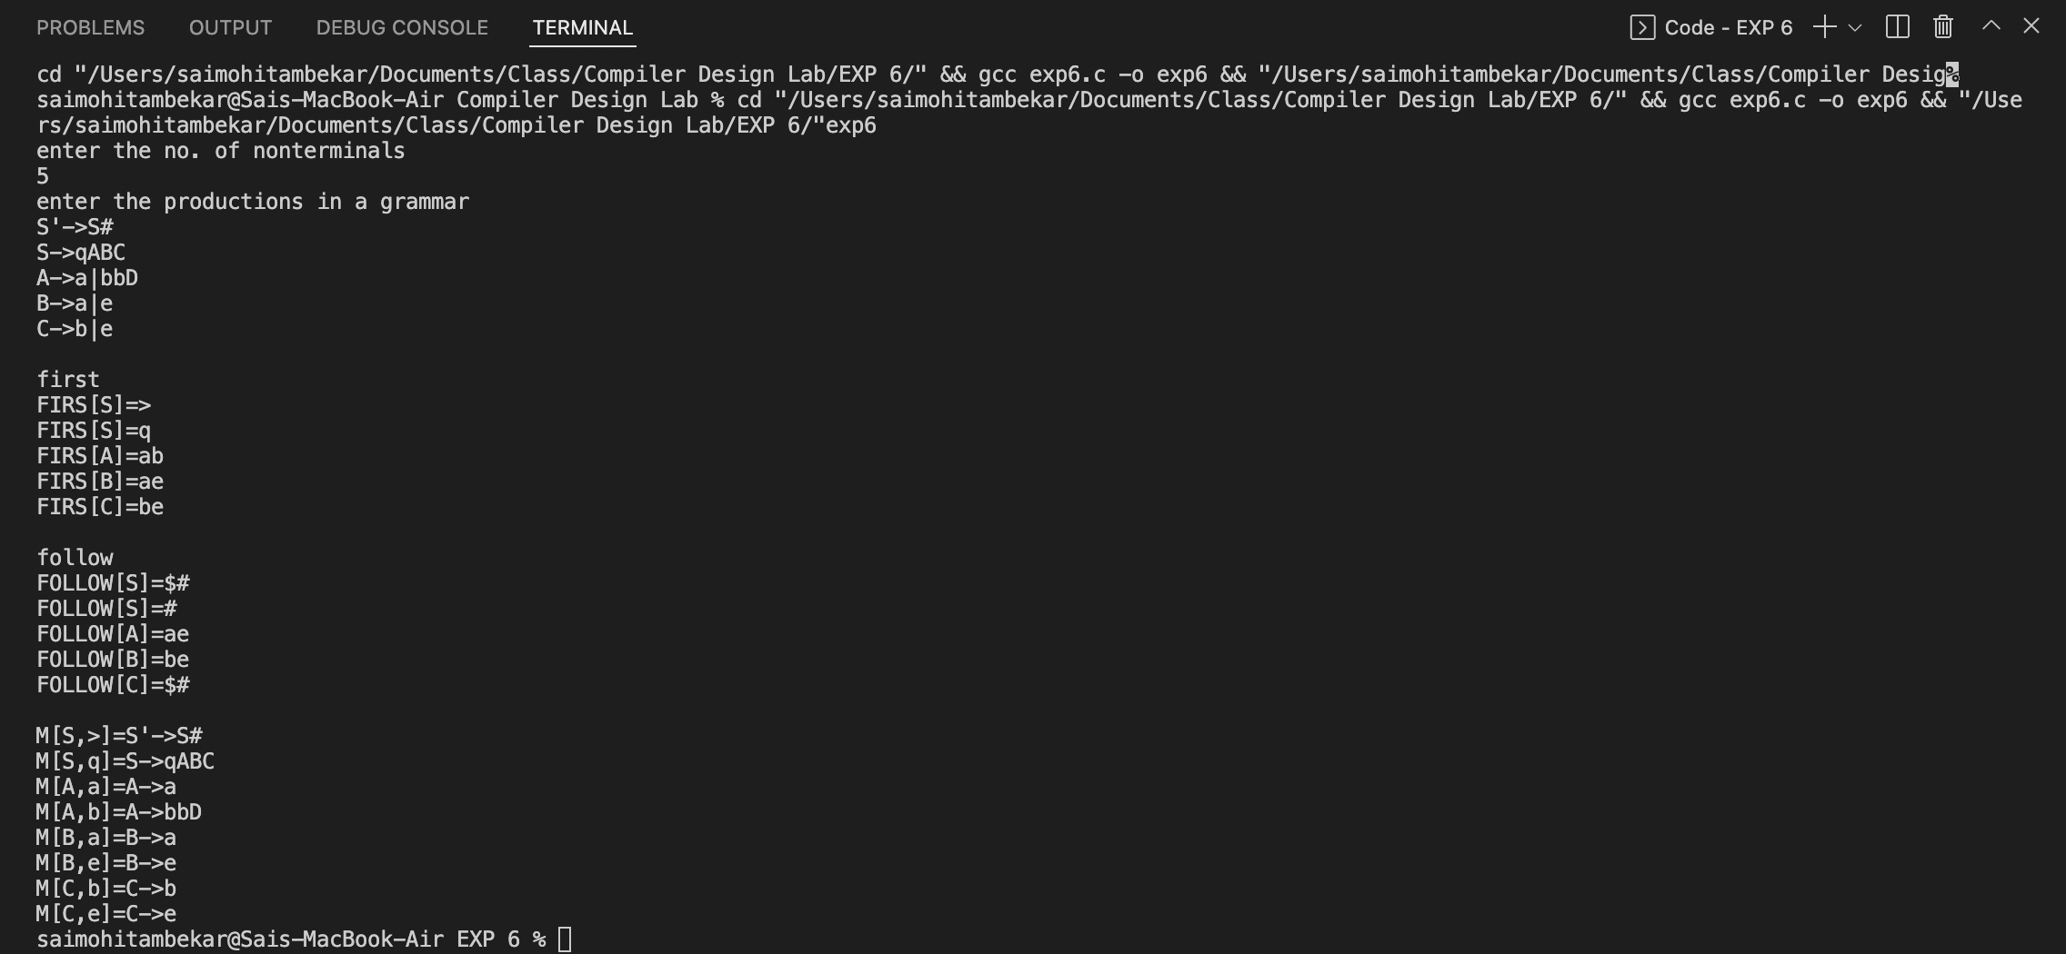

**Result:**

The predictive parsing table program was successfully compiled and executed.